Installing a Wireless Network in the Hotel

A report by Joel Parkinson 427075

Sally Chester is wishing to install a wireless network into the hotel which she would then offer to the clients of the hotel at a cost per day/week basis. She wishes for further information to reinforce her choice of whether she should do this or not.

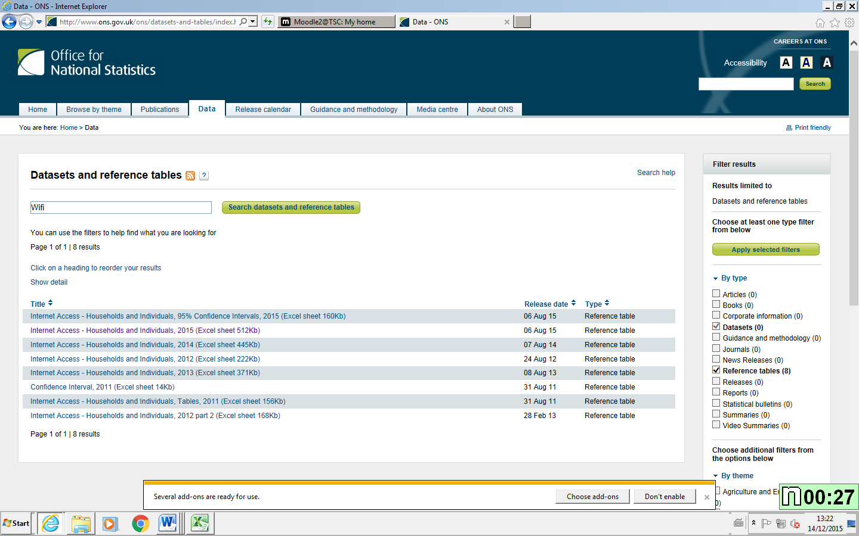I have chosen to look at the statistic of internet use ranging from 2006 to 2015 taken directly from the website: <http://www.ons.gov.uk> I will use the internet statistic information for the years mentioned above to create an overall usage graph to show how the amount of people using internet for personal uses has increased over the past few years.

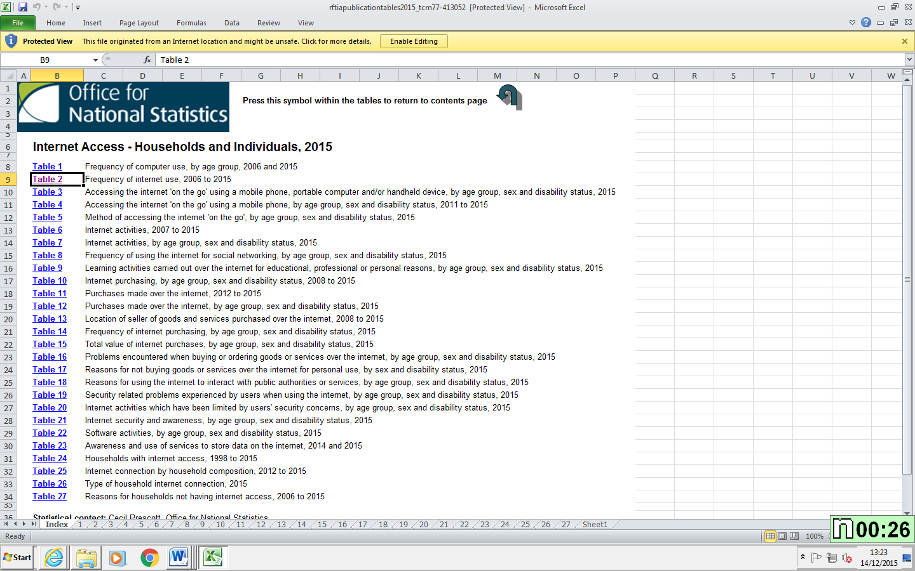Here you can also see an overview of the excel Spreadsheets that contain all the data I am going to use in this report.

The only check I did on the data is that of downloading two copies of the same data to make sure they both align perfectly to ensure no errors were made in downloading the data. I do not believe further checks of validity have to be done of this data as it is directly from a government website.

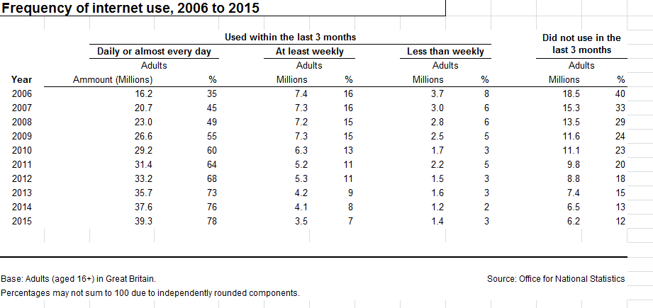

Here above are the raw stats as taken directly from the government website. I am going to use this table to illustrate how the amount of people using the internet on a daily basis has risen consistently over the past few years. I will also use it to illustrate how people are using the internet more frequently (daily instead of weekly). I have chosen this table data as it clearly displays the amount of people using the internet in the UK over a long period of time (9 years). It also shows the frequency that people are using it too (daily, weekly, less than weekly and did not use in the last week).

Illustrated Graphs and Report

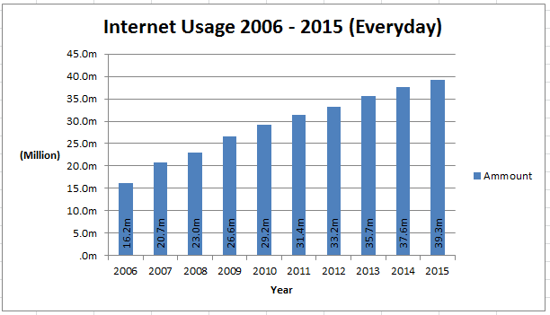

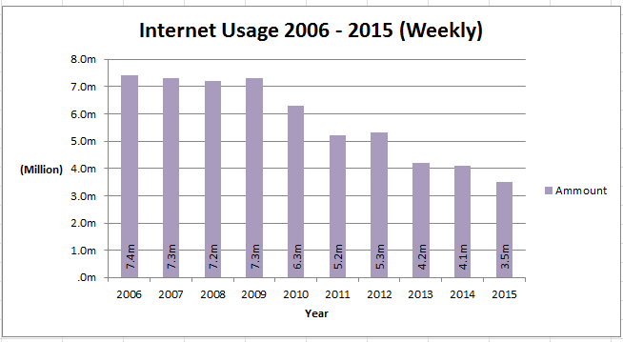Here are the two graphs I settled on creating from the data I collected from the UK Government website. This first graph is that of the amount of people that use the internet daily each year for the past 9 years. I have chosen this specific graph because it clearly illustrates how many people (in millions) use the internet in the UK alone on a daily basis. This graph also shows a consistent increase in the amount of people using the internet over the past few years and will be helpful towards illustrating the fact that more and more people are using the internet on a daily basis each and every year.

Here I have created another graph that shows a decrease in the amount of people that use the internet on a daily basis. This is most likely being caused by the increase in the amount of people using it daily instead. This goes to help illustrate that more people are using the internet every day. The amount is again in millions and the year ranges from 2006 to 2015.

This graph shows the overall percentage of people who used the internet in 2015 that used WIFI as the primary internet connection across these devices (Laptop, Tablet and P.C). This graph clearly illustrates the percentage as-well as the age range of people using WIFI. I have chosen this graph for two reasons; the first reason is that it shows the percentage of the already shown amount of people who use the internet and access it via WIFI; secondly I am using it to also illustrate separate age ranges that used WIFI.

This final graph is the same as the above graph however it instead looks at the percentage of people that use WIFI on their mobile phones. It also has the same age ranges for better illustration.

Justification of Information

Why I choose to use the information I did in Task 3.

# Why I chose the source:

Firstly where I gathered my data from was chosen because of the accuracy and reliability that said data came with. This is because the data comes directly form a government website that does studies on the impact of internet usage in the UK and has done so for the past 9 years. The data was gathered directly form: <http://www.ons.gov.uk>.

# What data I selected and why:

The data I selected was the 2015 [Internet Access - Households and Individuals](http://www.ons.gov.uk/ons/rel/rdit2/internet-access---households-and-individuals/2015/rft-ia-2015.xls) data Spreadsheet. I did this for a few reasons which I will list and say why below.

## Up to Date,

The data I chose was the most up to date available at the time of writing this document, this is incredibly important as it gives you the best figures of data for 2015 so I am better able to compare it to that of the other years. Another reason this is important is it allows you to get as much data as possible to create graphs that better depict any fluctuations that may be important to the interpreter.

## Multiple Different Tables from Source,

Each of the tables in the original Spreadsheet document I downloaded have different types of data that all relate to the overall internet usage figures for the past few years including 2015. This is important because it allowed me to pick out specific pieces of information a lot more easily than I normally would and gave me more sources of data to help justify the installation of a wireless network.

## Easily Accessible,

The Information I have chosen is also easily accessible in the event that Sally wants to either triple check my data for validity or wishes to use the same source of data I have, to check more statistics for herself. I believe this is important as it even though she may never need to access the source of data, she still has the option if she ever choses to.

## Large Review Base,

The information I used to create the graphs and will use to justify why Sally should implement a WIFI network in the hotel has a very large amount of people in it (multiple millions). This is very important when creating a graph and charts for justification purposes as it allows the overall graph to better depict the increase or decrease in internet and WIFI usage.

Business Decision Process

Why the information I have chosen supports the business decision process.

The main business decision here is whether or not it’s going to be worth the amount of money it costs to install the WIFI network for the hotel clients to use. During this business decision I am going to assume that you will be charging clients to use the WIFI on a per stay basis or daily basis.   
(It is not stated if she is or not in the scenario)

# Evidence Reasoning:

The evidence I decided to go with was that of internet statistic and WIFI usage statistics that also directly link to the internet usage statistics. I have chosen these two areas because the WIFI is what Sally is considering to implement and the internet statistics were the most in depth I could find (with multiple millions of people all part of the statistics). This is going to help with the business decision process as it directly links to exactly what Sally is considering and also links directly to the clients that would be visiting.

# Graph (A),

This is a depiction of graph (A), I chose this graph for several reasons however the main reason is that is clearly depicts the overall internet usage of the UK. This will help with the decision making process because the thing people are going to use WIFI for is to access to internet for whatever reason they desire. As such this graph shows that there has been a steady increase in the amount of people who use the internet daily over the past few years. This is important when making a decision regarding WIFI as it shows you just how many people use the internet on a daily basis which means that even if someone is staying for one or even two nights, there is a very high chance that that client may purchase WIFI access from the Hotel.

# Graph (B),

This is a depiction of my second graph (Graph (B)). This graph goes hand in hand with graph a as it is the same internet usage based graph however this time it shows the amount of people that use the internet however only weekly this time. The reason this is going to help in the decision making process is because it shows that there has been a steady decrease in the amount of people who only use the internet weekly while (as shown above) there has been the a very similar in pattern increase in the amount of people using it daily. This goes to show that more and more people are relying and are using the internet more frequently, which goes to reinforce the fact that people would pay for wireless internet if they had the chance to do so.

# Graph (C),

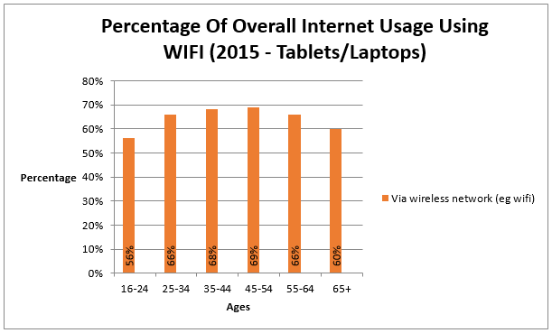This graph shows the percentage of people that use the internet from graph (A) that also use WIFI as the only way to access the internet or use it alongside other mediums of connection on a daily basis. This graph is that of people that use WIFI on tablets and laptop devices. It also includes several different age ranges. The reason I have created this particular graph instead of a simple WIFI usage one is because Sally can use this graph to see what amount of people from a particular age group visit the hotel and then compare that information against the percentage of that age group that use WIFI on a daily basis. This is going to help with the decision making process as it shows clearly that it isn’t just kids that use WIFI too access the internet from there tablets and laptops, it also goes to show just how many people that may bring laptops or tablets with them for their stay are likely to use WIFI. This graph could also be applied to the amount of business customers that come to the hotel as they’re more likely to bring laptops for work purposes and are also more likely to require internet access on their laptops for work purposes.

# Graph (D),

This is the final graph that I have produced for Sally, this graph is much the same as graph (C) however it depicts the amount of people that use WIFI via their Mobile phones. The reason I have chosen to include this and the reason I think it will go towards helping make a business decision is because of how technology has progressed over that past few years. A few years ago, a mobile phone would have been something not many people had and those that did have them probably used them for calling and texting and little else. However over the past 3 years or so there has been a massive increase in the amount of things you can do with a mobile phone, one of the things that a lot of people use their phones for now is social networking and browsing the internet itself. Social networking is something that you have to have internet access for and is something that a lot of people (old and young) do on a daily basis, it’s also something someone would do a lot when on a holiday which is the kind of person that would stay at a hotel such as the Salchester Arms. As such this graph helps show that the amount of people using their mobile phones to access the internet via WIFI is very large and the one device nearly everyone carries with them at all times in this day and age is also a mobile phone. This makes it easier to make a decision to implement a WIFI network into the hotel as you can see that there are a lot of people that would be able to take advantage of said infrastructure, these people would be a lot more likely to purchase WIFI access from the hotel.